**CODE:-**

#include <iostream>

using namespace std;

void divide(int a, int b)

{

cout << "Inside function.\n";

try

{

if (b != 0)

{

cout << "Result of division is :" << float(a) / b << endl;

}

else

{

cout << "Error.Throwing..." << endl;

throw b;

}

}

catch (int i)

{

cout << "Cannot handle the exception.Rethrowing..." << endl;

throw;

}

}

int main()

{

try

{

divide(5, 3);

divide(10, 0);

}

catch (int j)

{

cout << "Caught the exception :" << j << endl;

}

return 0;

}

**CODE:-**

#include <iostream>

#include <iomanip>

using namespace std;

void test(int x)

{

try

{

if (x == 1)

throw x; // int

else if (x == 0)

throw 'x'; // char

else if (x == -1)

throw 1.0; // double

else

throw "x";

}

catch (int m)

{

cout << "Caught int " << m << endl;

}

catch (char c)

{

cout << "Caught char " << c << endl;

}

catch (double d)

{

cout << "Caught double " << fixed << d << endl;

}

catch (...)

{

cout << "Caught default exception " << endl;

}

}

int main()

{

test(1);

test(0);

test(-1);

test(2);

return 0;

}

**OUTPUT:-**

(A)

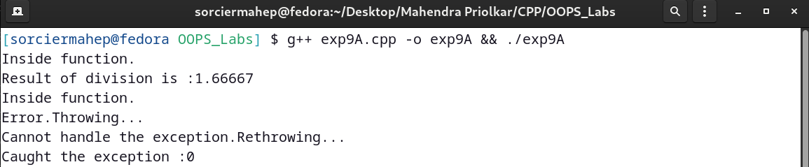

(B)

